**Applications of Multi-Variable Calculus in Computer Science**

1. **Midpoint Circle Algorithm:**

When computer graphic designers work on any project, they encounter many shapes. The most important shape is a circle, which we render as we desire. This whole thing is possible with the help of multiple rendering algorithms. These algorithms contain multiple variables and complexities with defining properties. To understand the algorithm, we must know multivariable calculus.

Today we will discuss one of these rendering techniques i.e. the Midpoint Circle Algorithm. We will discuss in detail the working of the rendering process of the circle via midpoint. Let’s dive into the algorithm explanation

Assuming the circle has an integer radius ‘R’ and is centered at the origin. For a circle not centered at the origin, we can translate each pixel the algorithm generates by (xc,yc), where (xc,yc) represents the integer coordinates of the circle's center.

The algorithm generates pixels in the second octant (where an octant refers to a quadrant divided into two parts) and uses symmetry to create the pixels in the remaining seven octants. To illustrate the algorithm, consider a circle with a radius of 15 centered at the origin. Figure 1.1 depicts the portion of the ideal circle and the pixels generated by the algorithm in the first quadrant. The algorithm starts by plotting the pixel at (x,y) = (0,R). It then chooses between the pixels (1,R) and (1,R−1). It then plots the pixel closest to the ideal circle. This process repeats as long as y>x, generating one pixel for each octant, resulting in a total of eight pixels.

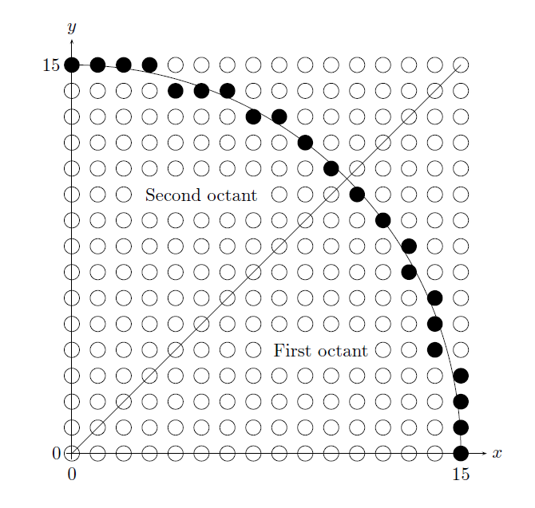

Figure .1 (Jordansson, 2024)

Now, consider Figure 1.2, which provides a detailed view of an intermediate step in the algorithm. Assume the pixel at (xp,yp) has already been plotted. To determine the next pixel, the algorithm considers two options: East and southeast. To decide, it evaluates whether the midpoint M=(xp+1,yp−1/2) lies inside or outside the ideal circle. If M is outside the circle, the algorithm selects pixel that lies southeast, as it is closer to the circle. If M is inside or exactly on the circle, either east or southeast can be chosen. In the figure 1.2, southeast will be selected.

To determine whether MMM is inside or outside the circle, the implicit equation of a circle is used, given by: